Title: EKF-Guided Chain-Reaction Interception for Target Reacquisition in Swarm-Based Wireless Sensor Network
Author: Yeqi Sang
- Problem Statement
In a typical swarm-based wireless sensor network (WSN), the number of mobile sensors is significantly larger than the number of tracked targets. From prior experiments (e.g., Naeimeh’s simulation), even with multiple simultaneous targets, fewer than one-third of the sensors are actively engaged in tracking or interception at any given time. For example, in a network of 25 sensors with 3 active targets, most sensors remain in an IDLE state.
This observation motivates the question of whether these unused sensors can be leveraged more effectively to improve target reacquisition when a target escapes the sensing range. Instead of allowing sensors to remain idle, we propose using them to support a chain-reaction interception mechanism, where additional interceptors are progressively recruited when initial interceptors fail to reacquire the target.
The proposed development proceeds in three phases:
Phase 1 — Single-Target Chain-Reaction Interception:
Implement and validate the core chain-reaction mechanism for the single-target case, where failed interceptors trigger the recruitment of additional nearby sensors, forming a decentralized, multi-stage interception cascade.
Phase 2 — Multi-Target Interception with Basic Conflict Handling:
Extend the chain-reaction mechanism to the multi-target case. Since multiple targets may attempt to recruit the same sensor, a simple first-come-first-served policy will be used initially to resolve conflicts between multiple target related issues.
Phase 3 — Multi-Target Interception with Optimized Bidding:
In the multi-target case, the bidding process for each individual target can remain simple. The main challenge arises when multiple targets attempt to recruit the same sensors. Therefore, Phase 3 focuses on developing a real-time-friendly, optimized multi-target bidding mechanism that resolves sensor–target conflicts and enables each sensor to decide which target it should assist based on local utility comparisons.
In the earlier version of the proposal, a distributed search mode was planned for recovery after tracking failure. However, given the WSN configuration and the EKF-based prediction capability, a full search mode is not needed for the current scope. Since the target’s motion can be predicted, a strengthened interception strategy—rather than wide-area search—is more appropriate and efficient for this system.
The project will be carried out using the FSM framework that I developed, which extends and restructures the design of Naeimeh’s earlier code. Implementing chain-reaction interception necessitates significant architectural changes, making it more appropriate to work from my own version. Nevertheless, her implementation will be retained for baseline comparison in the evaluation phase.

- Phase 1 Methodology
Phase I focuses on designing and validating a decentralized chain-reaction interception mechanism for a single target. The goal is to ensure that when the primary interceptor fails, additional sensors are recruited in sequential “rounds,” forming a multi-stage pursuit cascade that increases the likelihood of reacquisition without invoking a wide-area search mode.
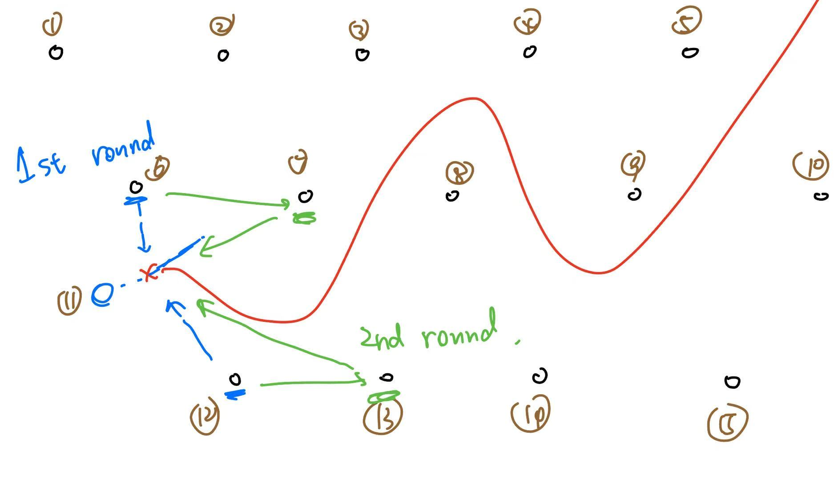
In this scenario, the main tracking sensor (Sensor 11) loses the target, predicts the target’s trajectory, and computes the intercept point. It then selects Sensor 6 and Sensor 12 as the first-round interceptors.
From there, Sensor 6 recruits Sensor 7 from its neighboring sensors as a second-round interceptor, and similarly, Sensor 12 selects Sensor 13. As more sensors join the interception chain, they approach the target from multiple directions, which reduces the probability of losing the target again—especially if the target changes direction abruptly.
In this case, the interceptor bidding process can remain relatively simple, because the chain-reaction interception strategy inherently provides higher tolerance to individual interceptor failures.
Three main points should be focused on:
1. What’s the bidding process for selecting sensor to intercept.
When the active tracking sensor loses the target, it immediately uses the EKF to predict the target’s future position and determine a corresponding intercept point. The tracker then recruits two initial interceptors through a bidding process.
The bidding process can remain lightweight and computationally efficient for real-time execution, since the chain-reaction interception strategy provides higher tolerance to individual interceptor failures.
# TODO
2. Under what conditions should an interceptor initiate the recruitment of additional nearby sensors, and when?
# TODO
3. When should the recruitment process terminate for a given target, and what should be done with interceptors from previous rounds?
# TODO

Three targets, more interceptors ( dynamic interceptors number …)
Optimization, conflict resolution scenario. Sub optimal (write an email to confirm). ..
I picked different metrices, to show the optimization. (acceptance criteria.)
Videos: https://www.mathworks.com/videos/understanding-discrete-event-simulation-part-1-what-is-discrete-event-simulation--1494873178760.html

